# Audacity Cheatsheet

You can work with multiple tracks in Audacity.

Here is what two tracks in Audacity look like:

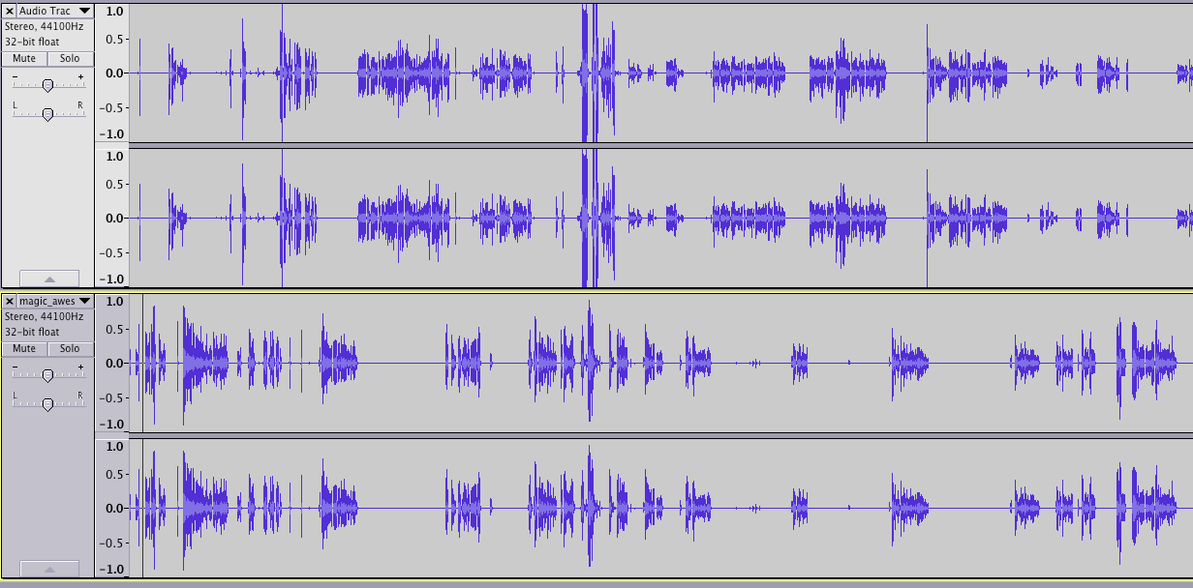

Each track has two channels, one for each ear. But we won’t have to worry about that for now.

Here are some useful shortcuts to begin:

|  |  |  |
| --- | --- | --- |
| Windows | Mac | Action |
| CTRL-1 | CMD-1 | Zooms into the track |
| CTRL-3 | CMD-3 | Zooms out of the track |
| CTRL-2 | CMD-2 | Resets the Zoom |

## Playing tracks

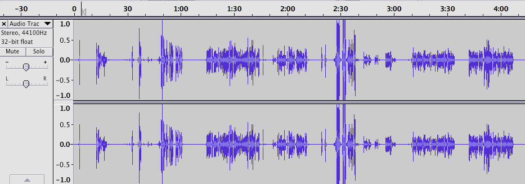

Click on the time to start playing automatically from that point.

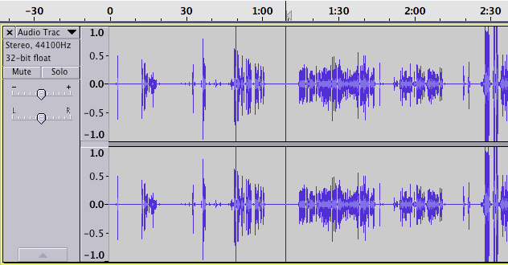

Click on the track and press space to start playing from that point.

Press space again to return to the same point and playing again.

## Selecting parts of a track

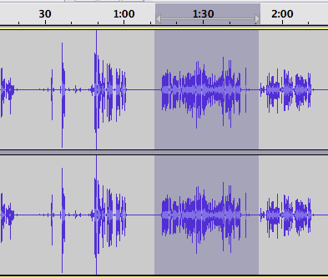

Click and drag to highlight a portion of the track.

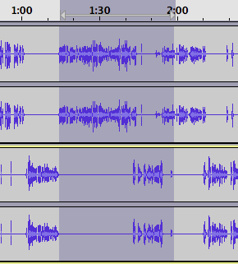

Click and drag across tracks to highlight the same area in multiple tracks.

Once a track is highlighted, if you press the spacebar, it will start playing from the start of the highlight and stop playing at the end of the highlight.

You can also copy or cut the highlighted portion. Press CTRL-C (CMD-C) to copy,

or CTRL-X (CMD-X) to cut that portion of the track.

## SILENCE!

You can add silence to your track by clicking on the track at the position you wish to add the silence, then click on Generate -> Silence, enter the number of seconds of silence you want. And viola! Silence in your track.

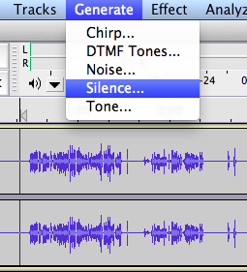

You can also convert a part of your track into silence, for example a cough or an “UMM…”. Highlight the portion you would like to silence, and press CTRL-l (CMD-l). (That’s a lowercase L).

## Effects

You can add effects to your sound tracks by highlighting a portion of the sound track and selecting an effect from the Effect menu. For our purposes, we will want to Fade Out our Intro as our podcast begins, and Fade In our Outro as our podcast ends. There are many effects in Audacity. Feel free to play with them!

